The STP decision-making tool is a simple method for thinking through a proposal or project and organizing it in a way that facilitates decision-making with a leader. The goal is to help make more informed and rational decisions by considering relevant information and potential options. Oftentimes, the information provided will result in a discussion that leads to an improved or alternative proposal.
This tool is often used at a team or department level, and is used quite frequently in healthcare systems. For a more complex project or decision, or at a unity/school or enterprise level, the Strategy A3 tool may be more helpful.
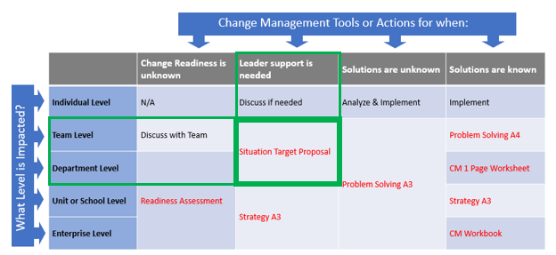
STP
or
SBAR

Once the sections of the tool are filled out, they can be presented to the leader in an email, memorandum, or PowerPoint presentation. The template and instructions for each section are below. On subsequent pages we have provided several examples:
Situation
The current situation involves the need to clearly define and communicate the context of the decision. This includes identifying the factors at play, the relevant parties involved, and any existing constraints or limitations. Without a shared understanding of the situation, stakeholders may lack the information necessary to move forward effectively.
Background
The desired outcome is to reach a clear and actionable decision that produces measurable results. A successful outcome would include consensus among stakeholders on the goal, alignment with broader organizational priorities, and clarity on what “success” will look like. This clarity ensures that actions taken will be both purposeful and sustainable.

Assessment
To achieve the desired outcome, a structured course of action is required. This should include a detailed plan, along with identification of potential risks, challenges, and mitigation strategies. Depending on the scope of the project, the plan may be high-level, focusing on milestones, or more granular, detailing specific tasks. Considerations should include stakeholder engagement, resource availability, and potential barriers that could delay or derail progress.
Recommendation
The recommended approach is to implement the proposed plan while maintaining flexibility to adapt to unforeseen challenges. By setting clear milestones, monitoring progress, and actively addressing risks as they arise, the team can ensure forward momentum. Regular communication with stakeholders and alignment with organizational objectives will be critical for success.

Examples for absenteeism, assigning teaching aides, and turnover proposals on next pages:

Example 1 – Employee Absenteeism
Situation
Our company is experiencing high rates of employee absenteeism. This trend is reducing productivity and increasing costs across several departments. Employees have cited poor work-life balance and high levels of stress as primary reasons for their time away from work.
Background
Absenteeism not only affects team performance but also raises operational expenses. Improving morale and ensuring healthier work-life balance are key goals in addressing the issue. The desired outcome is to reduce absenteeism while creating a supportive environment where employees can thrive.
Assessment
A flexible work policy has the potential to address these challenges. Allowing employees to work from home or adjust their schedules can improve balance, while stress management training and an employee assistance program can provide critical support. Risks include the possibility of reduced productivity if remote work is not well managed or if policies are misused.
Recommendation
Implement a flexible work policy with clear guidelines and monitoring to ensure accountability. Provide training on stress management and work-life balance, and establish an employee assistance program. Regularly review productivity data to track outcomes and make adjustments as necessary.

Example 2 – Teaching Aide Assignments
Situation
Faculty members have raised complaints about the current process of assigning teaching aides. The process is cumbersome, often takes too long, and frequently results in last-minute assignments.
Background
Delays and inefficiencies in aide assignments create frustration for faculty and disrupt planning for instruction. The goal is to improve the process so it is more efficient, transparent, and effective. Data on the time currently required for assignments will also need to be captured, since this is not yet known.
Assessment
An in-house online system could simplify and streamline the assignment process. Such a system would allow faculty to request aides, aides to state availability and preferences, and administrators to manage and track assignments. Risks include system adoption challenges and potential technical issues, but these can be mitigated with training and phased rollout.
Recommendation
Develop and implement an in-house online system to manage teaching aide assignments. Build functionality for requests, preferences, and notifications, and ensure the system supports administrative tracking. Provide user support and training to encourage adoption, and evaluate effectiveness after implementation.

Example 3 – Employee Turnover
Situation
The team is struggling with high turnover, leading to the loss of experienced staff. Exit feedback points to a lack of career growth opportunities and limited support from management as the main reasons for leaving.
Background
Losing experienced employees undermines team capacity and increases recruitment and training costs. The desired outcome is to improve employee retention and satisfaction by fostering career development and strengthening management support.
Assessment
Introducing a mentoring program, career development plans, and enhanced manager training would address the core issues. The main risks are that mentoring could be ineffective or managers may not fully engage in the support programs. These risks can be mitigated by careful mentor selection, structured training, and ongoing program evaluation.
Recommendation
Launch a mentoring program that pairs experienced employees with new staff, while also providing managers with training to improve guidance and support. Establish career development plans and professional development opportunities for all employees. Monitor results through retention and satisfaction data, adjusting the program as needed.

