BENEFITS SUMMARY

PAID TIME OFF (PTO) ACCRUAL | Professional and Support Staff (PSS) accrue PTO as follows:  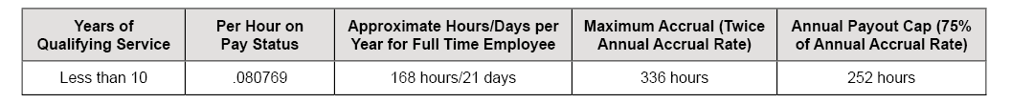  Senior Managers, Managers, and Senior Professionals (SMG/MSP) accrue PTO as follows:  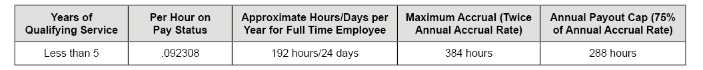  *Hours on pay status, including paid holidays, but excluding all paid overtime hours. **Based on full time statue.
EXTENDED SICK LEAVE (ESL) ACCRUAL | An eligible employee earns ESL from the date of eligibility based on the number of hours on pay status as follows:
DENTAL INSURANCE | Cost 100% covered by UC.
VISION INSURANCE | Cost 100% covered by UC.
BASIC LIFE INSURANCE | Automatic enrollment. Basic Life cost 100% covered by UC.
BASIC DISABILITY | Automatic enrollment. Basic Disability cost 100% covered by UC.
MEDICAL INSURANCE | You and UC share the costs of your medical plan premiums — except for CORE, which is paid for entirely by UC. Your share of the premium depends on your full-time salary rate, the plan you choose, your level of coverage, and your employee group. Refer to page 3 of this document to see the monthly employee contributions for UC medical plans in 2024.
PRIMARY RETIREMENT PLAN | 2016 Retirement Choice Program (Pension Choice and Savings Choice) - You must make your selection within 90 days.  Savings Choice: Employee contributes 7% and UC contributes 8% up to the annual IRS pay maximum.  Pension Choice: Employee contributes 7% and UC contributes a portion of your eligible pay, as determined by the UC Regents, up to the PEPRA maximum.

Continued on Page 2: Supplemental Retirement Plans and Supplemental Benefits

BENEFITS SUMMARY CONTINUED

SUPPLEMENTAL RETIREMENT PLANS | Option to enroll in voluntary Retirement Savings Programs record kept by Fidelity including: 403(b), 457(b), and Defined Contribution Plan (DCP) after-tax retirement savings plan.
SUPPLEMENTAL BENEFITS | Option to enroll in employee paid supplemental benefits including: Voluntary Short-Term Disability, Voluntary Long-Term Disability, Supplemental Life, Dependent Life, Accidental Death & Dismemberment, Supplemental Health Plans, Health Flexible Spending Account, Dependent Care Flexible Spending Account, Legal Plan. Visit https://ucnet.universityofcalifornia.edu/ for more information.

MEDICAL PLAN OPTIONS BY PAY BANDS
Choose the appropriate salary tier below to see the monthly employee contributions for UC medical plans in 2024.
PAY BAND 1 |  |  |  |  | PAY BAND 2
Medical Plans – $68,000 and under |  |  |  |  | Medical Plans – $68,001 to $136,000
 | Self | Self + Child(ren) | Self + Adult | Self + Adult & Child(ren) | Self | Self + Child(ren) | Self + Adult | Self + Adult & Child(ren)
UC Blue & Gold HMO | $99.69 | $178.33 | $280.64 | $358.63 | $144.81 | $259.03 | $380.55 | $493.80
Kaiser HMO | $36.49 | $65.60 | $110.33 | $136.84 | $84.69 | $152.26 | $262.15 | $323.23
UC Health Savings Plan (HSA) PPO | $79.26 | $129.75 | $180.81 | $227.92 | $186.73 | $305.61 | $436.31 | $546.62
UC Care PPO | $212.95 | $380.49 | $514.84 | $682.95 | $261.05 | $466.43 | $621.03 | $827.07
CORE PPO | $0 | $0 | $0 | $0 | $0 | $0 | $0 | $0
PAY BAND 3 |  |  |  |  | PAY BAND 4
Medical Plans – $136,001 to $204,000 |  |  |  |  | Medical Plans – Over $204,000
 | Self | Self + Child(ren) | Self + Adult | Self + Adult & Child(ren) | Self | Self + Child(ren) | Self + Adult | Self + Adult & Child(ren)
UC Blue & Gold HMO | $191.10 | $341.83 | $470.10 | $619.48 | $239.04 | $427.59 | $562.87 | $749.68
Kaiser HMO | $134.16 | $241.20 | $398.20 | $496.54 | $185.38 | $333.30 | $539.17 | $676.08
UC Health Savings Plan (HSA) | $297.01 | $486.08 | $665.28 | $842.96 | $411.20 | $672.98 | $902.52 | $1,149.94
UC Care PPO | $310.41 | $554.63 | $716.19 | $961.08 | $361.52 | $645.96 | $814.79 | $1,099.90
CORE PPO | $0 | $0 | $0 | $0 | $0 | $0 | $0 | $0

